What is a Public Involvement Plan?
A Context Sensitive Solutions (CSS) Public Involvement Plan (PIP) serves as the roadmap for meaningful public participation throughout a study/project's lifecycle. It contextualizes the study/project and documents how the study/project team will identify stakeholders, communicate study/project information, gather public input, and incorporate community perspectives into study/project decision-making.
This template is intended to guide consultant teams in preparing complete, consistent, and study/project-specific Public Involvement Plans that align with NMDOT's Public Involvement Portal and Toolbox. Each section should be tailored to the study/project's unique purpose, setting, stakeholders, and level of public involvement. Update the PIP throughout study/project development as new information becomes available or public involvement activities evolve.
This Public Involvement Plan (PIP) template was developed for NMDOT, in alignment with NMDOT’s Design Manual, Location and Study Procedures, and Involvement guidance found on NMDOT’s Public Involvement Portal and ToolBox. See below for a reminder of the components of an Effective Public Involvement Plan:
Define the study/project limits, purpose, and surrounding context.
Identify stakeholders, affected communities, and key issues or commitments.
Establish public involvement goals and context-sensitive engagement strategies.
Select public involvement activities appropriate to the study/project phase and community context.
Implement, document, and monitor public involvement activities throughout study/project development.
Evaluate results and incorporate public input into the study/project decision-making proces


PUBLIC INVOLVEMENT PLAN
A Template for NMDOT Projects
Study/Project Name, (If applicable, include the Study/Project Phase)
Control Number (CN)
Study/Project Location, including highway and Mileposts (MP)
Prepared for:
New Mexico Department of Transportation (NMDOT)
(Include NMDOT logo)
(If federally funded, include the Federal Highway Administration (FHWA))
Prepared by:
(Name and/or logo of firm)
Date (Month, Year)

Table of Contents
1. Introduction 4
1.1 Study/Project Area Description 4
1.2 Public Involvement Goals & Objectives 4
2. Study/Project Context 4
2.1 Environmental Setting: 5
2.2 Historic & Cultural Setting: 5
2.3 Land Use and Ownership: 5
2.4 Visual Context 5
2.5 Transportation: 5
2.6 Community Profile & Demographics: 5
3. Public Involvement Approach 6
3.1 Public Involvement Strategy 6
3.2 Stakeholder Identification & Key Contacts 7
3.3 Public Activities 7
3.4 Outreach Strategies & Communication Methods 8
3.5 Study/Project & Meeting Materials 8
3.6 Study/Project Website 9
4. Prior Public Involvement 9
5. Comment & Commitment Tracking 9
6. Public Outreach Summary 10
7. Public Involvement Evaluation 10

1. Introduction
Provide a concise overview of the study/project and establish the foundation for the public involvement program. This section should help reviewers understand the study/project, its purpose, and the goals the public involvement effort is intended to achieve.

1.1 Study/Project Area Description
- Describe the study/project purpose and need in clear, concise language. If available, include the official Purpose and Needs statement, though this may not always be defined during early study phases.
- Explain why the study/project is being proposed and the transportation need or opportunity it is intended to address.
- Describe the study/project location (eg. County, road name and number), study limits, study/project termini (eg. Beginning and ending mileposts), and surrounding setting. Include relevant jurisdictional boundaries, land status (eg. State Trust, USFS, BLM), and nearby communities, landmarks, or other geographic features that help define the study/project area.
- Describe the study/project's current phase, anticipated future phases, funding sources (eg. State, federal, private), study/project proponent, and overall study/project schedule, as applicable.
- Include a USGS topographic map or an aerial map with study/project area footprint and land status, legend, and clear compass.
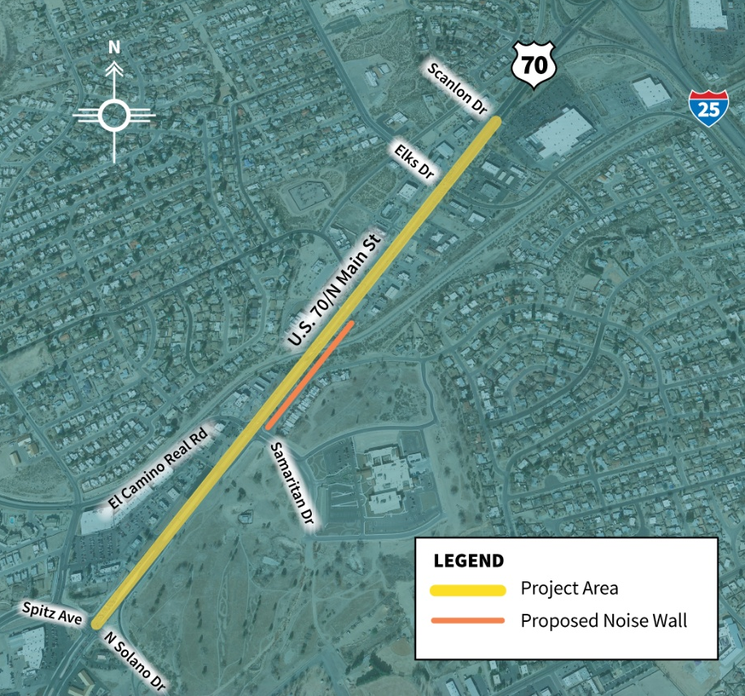

1.2 Public Involvement Goals & Objectives
- Clearly define the desired outcomes of the public involvement program. Goals should reflect transparency, accessibility, inclusiveness, regulatory compliance, and meaningful opportunities for public participation.
- Identify goals and objectives to identify possible concerns or challenges early in the project, to establish consensus on the study/project purpose and need, and to document decisions throughout the study/project process.
- Develop quantitative, measurable objectives that support study/project decision-making and align with the selected public involvement strategies and activities. These should be scaled and right sized for each study/project, with the goal of being able to define how a public involvement effort has been successful.
- Ensure the proposed public involvement activities are appropriate for achieving the identified goals and objectives.

2. Study/Project Context
The Study/Project Context establishes the foundation for the Public Involvement Plan by describing the physical, social, environmental, and transportation characteristics of the study/project area. Understanding the study/project context helps identify affected communities, potential issues, and opportunities for meaningful public involvement. Include relevant data, studies, and mapping, as appropriate, to support the selected public involvement approach.
Ensure this section is developed by referencing and citing relevant local planning documents. This includes comprehensive plans, transportation plans, regional development strategies, and community vision statements. These documents provide valuable insight into local priorities, planned improvements, community values, and long-term goals. Incorporating them helps to ensure study/project outcomes developed are aligned with established local direction.

2.1 Environmental Setting:
- Summarize environmental conditions within the study/project area that may influence study/project development or public involvement, including natural resources, wildlife, vegetation, water resources, air quality, cultural landscapes, or other visual and scenic environmental features, as applicable.

2.2 Historic & Cultural Setting:
- Summarize historic resources, community history, or locally significant events that may influence study/project development, public interest, or community identity. Recent history (0-20 years) that provides background and context should also be considered, such as fires, floods, or other natural disasters, as well as significant social events or tensions.
- Describe known or anticipated archaeological, cultural, tribal, or other sensitive resources that may influence study/project development or public involvement activities.
  - Cultural Resource Considerations: The consultant shall remember that the PIP is a public document. Therefore, no sensitive, confidential, or locationally specific cultural resource information should be presented. Only provide general descriptions appropriate for public release.

2.3 Land Use and Ownership:
- Describe existing land uses and ownership within the study/project area. Identify relevant jurisdictions, ownership patterns, and land management agencies that may influence study/project development, permitting, or stakeholder coordination.

2.4 Visual Context
- Consider specific visual contexts. Are there opportunities for gateway treatments? What type of landscaping, if any, is present? Are there any public art installations in the study/project area?

2.5 Transportation:
- Describe existing transportation conditions, including roadway classification, traffic characteristics, multimodal facilities, roadway users, safety concerns, operational conditions, and connectivity relevant to the study/project.
- Multimodal facility considerations include sidewalks, sidewalk conditions, bus routes, vehicular travel, airports, biking lanes, and walking paths.
- Review planning materials to determine if the study/project area is included in upcoming city, county, or state initiatives or developments. Examples include the Statewide Bike Plan and City or County planning documents.
- Utilize resources such as the American Association of State Highway and Transportation Officials (ASSHTO) Safety Dashboard to develop a data-driven profile of the study/project area. Specifically reference data pulled from this or other resources.

2.6 Community Profile & Demographics:
- Summarize the demographic characteristics of the study/project area using current and reliable data sources (e.g., U.S. Census Bureau). Consider population, age, household characteristics, race and ethnicity, income, languages spoken, educational attainment, households with or without vehicles, and other relevant community characteristics, such as literacy data or health data.
- Identify populations that may require targeted outreach, including Title VI and Environmental Justice communities, and determine whether bilingual study/project materials or other language access services are appropriate.
  - Language Access: The consultant shall assess language assistance needs using demographic data, local knowledge, and the project area of influence. When determining translation and interpretation needs, consideration should be given to the size and concentration of limited English proficiency (LEP) populations, project significance, expected public engagement, and Title VI requirements. As a general guideline, key outreach materials should be evaluated for translation when a language group represents about 5% or more of the affected population, though smaller populations may also warrant language services if they are geographically concentrated, underserved, or if translation is requested by the community, local representatives, or the project team.
- Include a formatted table, such as the example below, showing relevant data that informs the Community Profile from sources, such as the U.S. Census Bureau. Where possible, consider displaying study/project area profile and demographics to statewide data.

Demographic | Project Area | New Mexico
Population | … | …
Hispanic/Latino* | … | …
Households with Limited English Proficiency | … | …
Persons with a bachelor’s degree or higher | … | …
Average Income | … | …
Average Employment | … | …
Households with/without a vehicle | … | …
Etc… | … | …
*Include data on populations representing 5% or more of individuals within the project area.

Mapping & Supporting Figures
Include study/project location maps, study area maps, and other figures, as appropriate, to illustrate the study/project setting and surrounding context. Maps should include clear legends, scale, north arrow, labels, and consistent symbology. Figures should clearly identify the study/project area and be of publication-quality.

3. Public Involvement Approach
This section describes how the public involvement program has been tailored to the study/project's unique context, stakeholders, and objectives. The selected strategies, activities, and communication methods should support meaningful public participation, satisfy Context Sensitive Solutions (CSS) principles, and align with the study/project's phase, complexity, and anticipated level of public interest.

3.1 Public Involvement Strategy
- Describe the overall public involvement strategy for the study/project. Explain how the proposed activities support the study/project's goals and objectives, respond to the study/project context, and promote meaningful public participation throughout study/project development.
- Describe why each public involvement activity was selected and how it contributes to informed decision-making, stakeholder collaboration, and Context Sensitive Solutions principles.
- Where appropriate, identify opportunities to collaborate with local agencies, local public figures, community organizations, neighborhood groups, property owners, or other stakeholders to strengthen public involvement efforts.
Examples may include forming advisory groups, coordinating with local governments, conducting targeted stakeholder meetings, or hosting public meetings at key study/project milestones.

3.2 Stakeholder Identification & Key Contacts
- Identify the agencies, organizations, community groups, businesses, institutions, elected officials, land or property owners, and other stakeholders that may be affected by or have an interest in the study/project.
  - Landowner/Land Manager Engagement: Consultants should remember that landowners and land managers within the study/project area footprint have a distinct role in the decision-making process, compared to adjacent and near-by parties. Their involvement, responsibilities, and considerations differ and should be acknowledged accordingly.
- Describe how stakeholders were identified and explain how the study/project team will maintain and update stakeholder information throughout study/project development.
- Include an initial list of known stakeholders and potentially affected parties relevant to the study/project. Contact information is not required within this Public Involvement Plan and may be maintained separately as part of the study/project contact log.
Consider the following questions when identifying stakeholders:
- Who may be directly or indirectly affected by the study/project?
- Who should receive study/project information or have opportunities to provide input?
- Are there Title VI, Environmental Justice, tribal, limited English proficiency (LEP), or other underserved populations that require targeted outreach?
- Are there stakeholder groups that may require different communication methods, messaging, or levels of engagement throughout the study/project?
- What issues, concerns, or interests are anticipated for each stakeholder group?
Examples of stakeholders may include:
- Federal, state, tribal, county, and local agencies
- Local governments and councils
- Transportation authorities
- Elected officials
- Community organizations and advocacy groups
- Emergency responders
- Schools and higher education institutions
- Business owners and industry representatives
- Property owners
- Residents and neighborhood associations

3.3 Public Activities
- Identify the public involvement activities proposed for the study/project and explain how each activity supports the study/project's goals, objectives, and target audiences.
- Describe the purpose, timing, anticipated participants, and desired outcomes for each activity.
- Develop a public involvement program that begins with broad public awareness and progresses toward more targeted engagement as the study/project advances.
The following table may be used to summarize proposed public involvement activities:
Activity | Purpose | Target Audience | Timing
Public Meeting | Introduce the study/project, share study/project information, and gather community input. | Residents, businesses, property owners, and interested members of the public. | 30% design
Stakeholder Meeting | Discuss study/project-specific issues and gather technical or local knowledge from key stakeholders. | Local government representatives, emergency responders, utilities, tribal representatives, and partner agencies. | Prior to public meetings and throughout study/project development, as needed.

Activities may include public meetings, public hearings, stakeholder meetings, advisory committees, property owner meetings, pop-up events, virtual meetings, online engagement opportunities, or other study/project-specific outreach methods.

3.4 Outreach Strategies & Communication Methods
Describe the communication methods that will be used to inform the public and stakeholders about the study/project and invite them to upcoming engagement opportunities. Outreach methods should be appropriate for the study/project setting, target audiences, and level of public interest.
Examples may include:
- Email notifications
- Newspaper advertisements
- Social media
- Every Door Direct Mail (EDDM)
- Roadside banners or yard signs
- Direct mail
- Agency or partner communications
- Bilingual notifications, as appropriate
Describe the communication methods the public involvement program will use, identifying the purpose of each. When will the material be distributed or why will it be distributed? What core message will the material deliver? This section should articulate a strategy for garnering public participation.

3.5 Study/Project & Meeting Materials
Identify the public information materials that will be developed to communicate study/project information throughout the public involvement process. Materials should be appropriate for the intended audience and presented in a clear, accessible, and visually consistent manner.
Examples may include:
- Fact sheets
- Display boards
- Comment forms
- Study/Project presentations
- Frequently Asked Questions (FAQs)
- Maps and graphics
- Study/Project newsletters
- Digital content
The materials list should state what purpose each asset is generated for.

3.6 Study/Project Website
- Describe the purpose of the study/project website and identify how it will support the overall public involvement program.
- Identify who will be responsible for maintaining and updating website content throughout the study/project.
- Describe the information that will be available to the public, which may include:
  - Study/Project overview
  - Study/Project schedule
  - Study/Project maps
  - Technical documents, as appropriate
  - Upcoming public involvement opportunities
  - Public comment opportunities
  - Contact information
  - ADA and language assistance information
If a study/project website is not included, describe how study/project information will otherwise be made available to the public.

4. Prior Public Involvement
Summarize any previous public involvement activities or related planning efforts relevant to the study/project area. Previous outreach may include study/project scoping activities, prior public involvement efforts, agency coordination, planning studies, or other related initiatives.
Include, as applicable:
- Previous public involvement activities and outcomes
- Key stakeholder groups previously engaged
- Public comments, issues, or concerns raised
- Study/Project commitments or decisions resulting from previous outreach
- Lessons learned that should inform the current public involvement program
Explain how previous public involvement efforts have influenced the proposed Public Involvement Approach and how existing commitments will be carried forward, as appropriate.

5. Comment & Commitment Tracking
Describe the process that will be used to document, evaluate, and respond to public comments throughout the study/project. Establish a consistent approach for tracking comments and commitments to ensure stakeholder input is considered during study/project development and commitments made by the study/project team are documented and carried forward.
At a minimum, describe:
- How public comments will be collected and documented
- How comments will be reviewed and incorporated into study/project decision-making, as appropriate
- How study/project commitments will be documented, assigned, and monitored
- How comment and commitment records will be maintained throughout the study/project

6. Public Outreach Summary
Following the closing of each public comment period associated with a public meeting or public involvement activity, prepare a Public Outreach Summary for NMDOT review. The summary should document the outreach conducted, public participation, comments received, and study/project commitments resulting from the engagement effort.
Public Outreach Summaries should include, as applicable:
- Overview of the public involvement activities completed
- Methods used to notify the public and stakeholders
- Summary of public comments received
- Summary of study/project commitments made during the outreach process
- Meeting attendance records or sign-in sheets, as well as the number of event attendees
- Copies of public notifications, informational materials, and meeting displays
- Unredacted public comments, submitted as an appendix or supporting documentation, as appropriate
The Public Outreach Summary should provide a clear record of each public involvement effort and support study/project documentation throughout the life of the study/project.

7. Public Involvement Evaluation
Establish performance measures to evaluate the effectiveness of the public involvement program throughout the study/project. Evaluation should consider whether outreach activities successfully informed the public, engaged appropriate stakeholders, and supported meaningful participation in study/project development.
Consider the following when evaluating the public involvement program:
- Were the appropriate stakeholders identified and successfully engaged?
- Did the selected public involvement activities effectively reach the intended audiences?
- Were study/project information and key messages communicated clearly and effectively?
- Were opportunities for public participation accessible, inclusive, and appropriate for the study/project?
- Were stakeholder concerns identified, documented, and appropriately considered during study/project development?
- Were coordination efforts with agency partners and community organizations effective?
- What lessons were learned to improve future public involvement efforts?

Describe the methods that will be used to evaluate the public involvement program. Evaluation methods may include participant surveys, comment forms, stakeholder feedback, attendance data, website analytics, social media engagement metrics, or other study/project-specific performance measures.

